EXPT NO:6 | OVER-PLOTTING REDUCTION TECHNIQUES
DATE: 09.02.2026

PRE-LAB QUESTIONS

1.Why is over-plotting common in big data visualization?

Over-plotting occurs because big data involves millions of records while display screens have limited pixels. When too many data points share the same or similar coordinates, they overlap, making it impossible to distinguish individual marks.

2.How does data density affect perception?

High data density can create "visual noise," where the viewer perceives a solid mass instead of a distribution. This obscures the frequency of data, often leading the viewer to ignore the underlying patterns or the true concentration of values.

3.What trade-offs exist between detail and clarity?

Increasing detail by showing every data point often results in a cluttered, unreadable chart (loss of clarity). Conversely, improving clarity through aggregation or binning simplifies the message but hides specific outliers and individual variations (loss of detail).

4. How do AI datasets increase visualization complexity?

AI datasets are typically high-dimensional and massive in scale, making it difficult to project complex relationships into 2D or 3D space. This leads to extreme over-plotting and "feature overlap," where critical correlations become visually buried.

5. Why is over-plotting a serious analytical risk?

Over-plotting is risky because it hides the true distribution of data, potentially masking critical clusters or fraudulent patterns. It can lead analysts to draw false conclusions by making a highly populated region look identical to a sparsely populated one.

OBJECTIVE : To apply techniques that reduce visual clutter in large-scale datasets.

SCENARIO A social media analytics company visualizes millions of user interactions to study engagement patterns.

IN-LAB TASKS (Using R Language)

1. Use aggregation

Code:

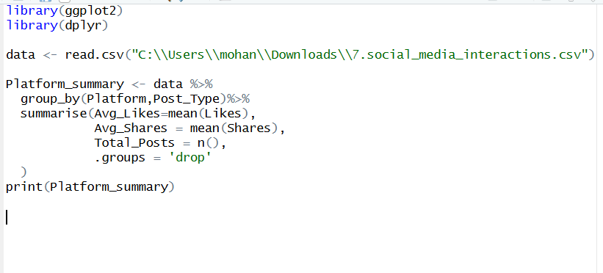

Output :
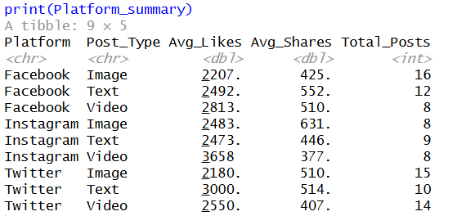

2.Binning:

Code:

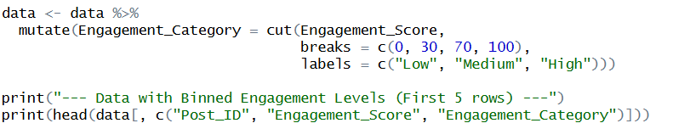

Output:
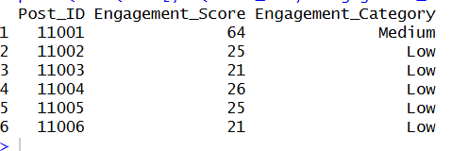

3. Jittering:

Code:
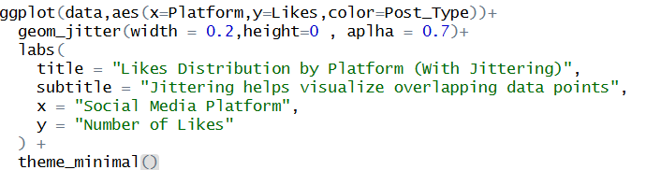
Output:

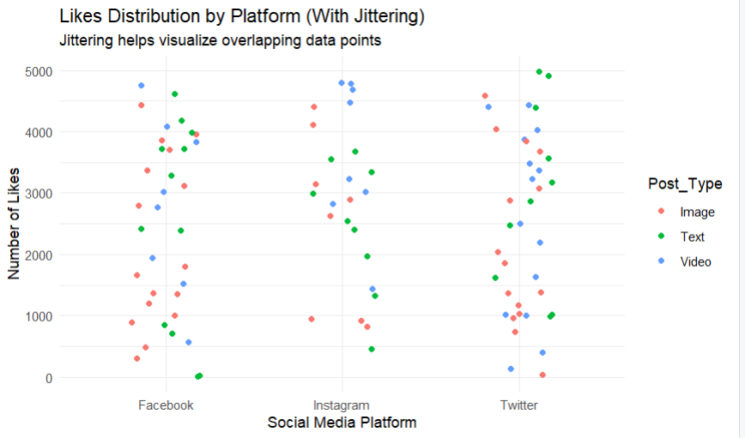
POST-LAB QUESTIONS

1.Which technique provided the best clarity and why?

Jittering provided the best clarity because it resolved over-plotting by slightly displacing overlapping points. This revealed the true density of interactions per platform that was previously hidden.

2. How does over-plotting distort analytical conclusions?

Over-plotting makes multiple data points appear as a single dot, leading to an underestimation of data volume. This distorts conclusions about the distribution, frequency, and variance of the dataset.

3. When should aggregation be preferred over raw plotting?

Aggregation is preferred when dealing with large-scale datasets where individual points create visual noise. It helps focus on high-level trends, such as average performance across categories, rather than specific instances.

4.How do these techniques support scalable AI analytics?

These techniques enable data reduction and feature engineering, allowing models to process summarized patterns instead of raw logs. Binning, specifically, converts complex continuous noise into simplified categories for better model training.

5.Explain real-world consequences of ignoring over-plotting.

Ignoring over-plotting can lead to misallocated resources in business or missed critical clusters in fields like healthcare. For example, a concentrated fraud attack might be ignored if thousands of overlapping malicious transactions appear as just one single event.

LEARNING OUTCOME: Students master over-plotting reduction for big data visual analytics.
ASSESSMENT
Description | Max Marks | Marks Awarded
Pre Lab Exercise | 5
In Lab Exercise | 10
Post Lab Exercise | 5
Viva | 10
Total | 30
Faculty Signature

